**Name: Sushant Tulasi**

**Class: D15B**

**Roll: 60**

**Lab 04**

**Aim:** To create an interactive Form using form widget

**Theory**

Form validation is an essential feature in mobile applications to ensure the correctness of user inputs before processing them. In Flutter, `Form` and `TextFormField` widgets are used to create forms with built-in validation capabilities.

**Key Concepts:**

**1. GlobalKey:** Used to uniquely identify the form and manage its state.

**2. TextFormField:** A widget that allows users to enter input and supportsvalidation.

**3. Validation Logic:** Defines conditions to verify the correctness of input.

**4. Submit Button:** Triggers form validation and processes the input if valid.

**Code Implementation**

import 'package:flutter/material.dart';

void main() {

runApp(MyApp());

}

class MyApp extends StatelessWidget {

@override

Widget build(BuildContext context) {

return MaterialApp(

debugShowCheckedModeBanner: false,

home: FormScreen(),

);

}

}

class FormScreen extends StatefulWidget {

@override

_FormScreenState createState() => _FormScreenState();

}

class _FormScreenState extends State<FormScreen> {

final _formKey = GlobalKey<FormState>();

final TextEditingController _nameController = TextEditingController();

void _submitForm() {

if (_formKey.currentState!.validate()) {

ScaffoldMessenger.of(context).showSnackBar(

SnackBar(content: Text('Form Submitted Successfully')),

);

}

}

@override

Widget build(BuildContext context) {

return Scaffold(

appBar: AppBar(title: Text('Form Validation Demo')),

body: Padding(

padding: const EdgeInsets.all(16.0),

child: Form(

key: _formKey,

child: Column(

children: [

TextFormField(

controller: _nameController,

decoration: InputDecoration(labelText: 'Enter your name'),

validator: (value) {

if (value == null || value.isEmpty) {

return 'Name cannot be empty';

}

return null;

},

),

SizedBox(height: 20),

ElevatedButton(

onPressed: _submitForm,

child: Text('Submit'),

),

],

),

),

),

);

}

}

**Output**

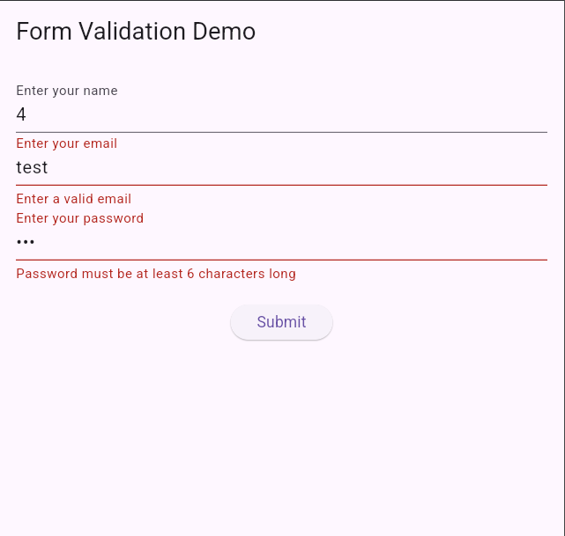

**Conclusion**

Form validation in Flutter can be efficiently managed using the `GlobalKey`, `TextFormField`, and validation functions. This ensures user inputs are validated before processing, improving app reliability.